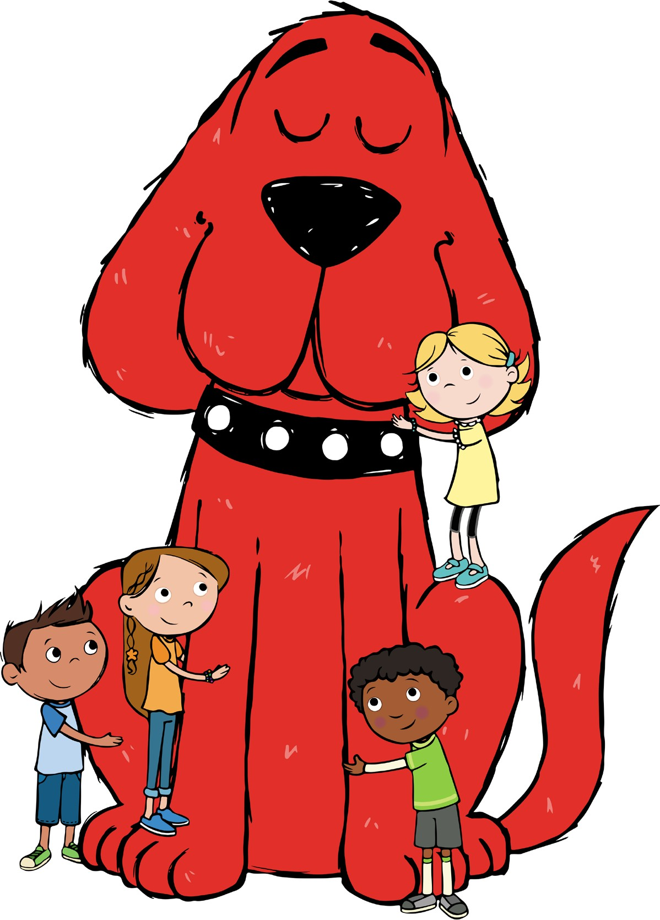

Thank You!

Our Scholastic Book Fair was a success! Thank you to all families, teachers, and students who participated, supporting our school while enhancing home libraries.

Your investment in your reader helped our school to earn valuable Rewards that can be redeemed for new books for our school and classroom libraries, as well as supplies and Education Resources to benefit our students.

We can’t wait to hear all about the new stories you have added to your home libraries!

Thank you for participating in our Scholastic Book Fair!

Happy reading!

